**NANDHINI MB**

**RDBMS ASSIGNMENT**

**7-01-2021**

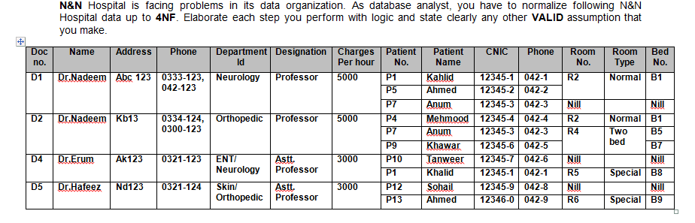

* Normalise the above table upto BCNF.
* Identify and mention the appropriate dependencies in each level of normalization.
* After every normalization level, illustrate the resulting tables with all values
* Elaborate each step clearly and mention any assumption you make to solve the problem.
* Answers can either be submitted as scanned copies of normalization done on paper or as documents where the tables are drawn using tools

**1NF**

1. No Multivalued, Composite Attributes
2. Atomic values
3. Same data type

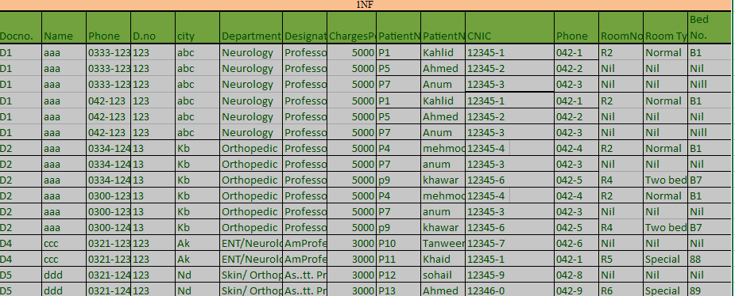

**2NF**

**Candidate key = {Docno, Phn, patientno, cnic}**

**Prime attributes = Docno, Phn, patientno, cnic**

No Partial dependencies (Docno,Phn, patientno, cnic <- (Docname, dno, city, department, designation, charges per hr, patientname, phone, cnic, room no, room type, bed no))

To be in 2NF all non-prime attributes should depend on whole candidate key, not only on a single prime attribute.

* 1. Docno, phn -> name, dno, city, dep, designation, charges per hr.
  2. PatientNo, cnic -> name, phone, room no, room type, bed no

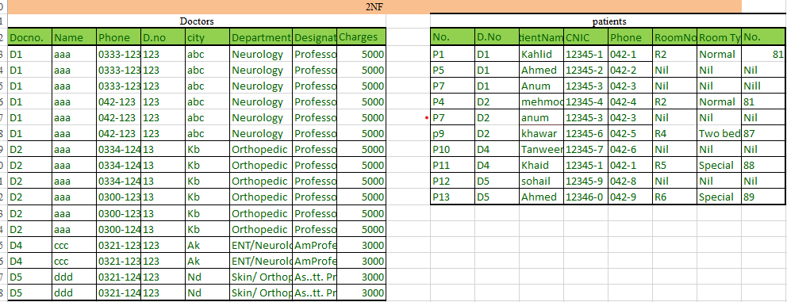

**3NF**

No transitive dependency(Patient no -> Room no -> bedno)

* 1. PatientNo, dno, cnic -> name, phone, room no, bed no, room type
  2. bed no -> room no, room type

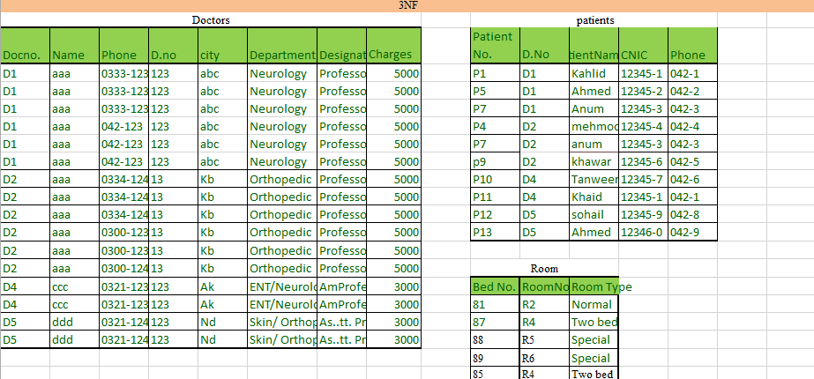

**BCNF:**

All determinant should be a super key(bed no -> Room no, Room type and room no -> room type (room no is not a super key))

1. bed no -> room type
2. bed no -> room no

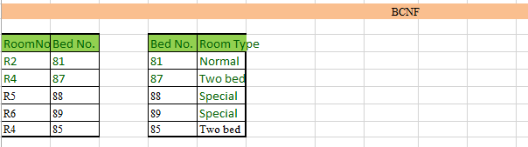

Final Design:



